Marathon Oil Corporation
Name of Student
Course
Date:

Marathon Oil Corporation
Introduction
A financial analysis refers to a process of assessing projects, budgets, businesses, and other finance-related transactions for purposes of determining their performance and consequent suitability. In a typical occasion, a financial analysis is performed to find out whether an organization is adequately solvent, liquid, stable, or profitable to merit a monetary investment (Zeller et al, 2019).
Horizontal Analysis
Table 1: Marathon Oil Corporation Horizontal analysis
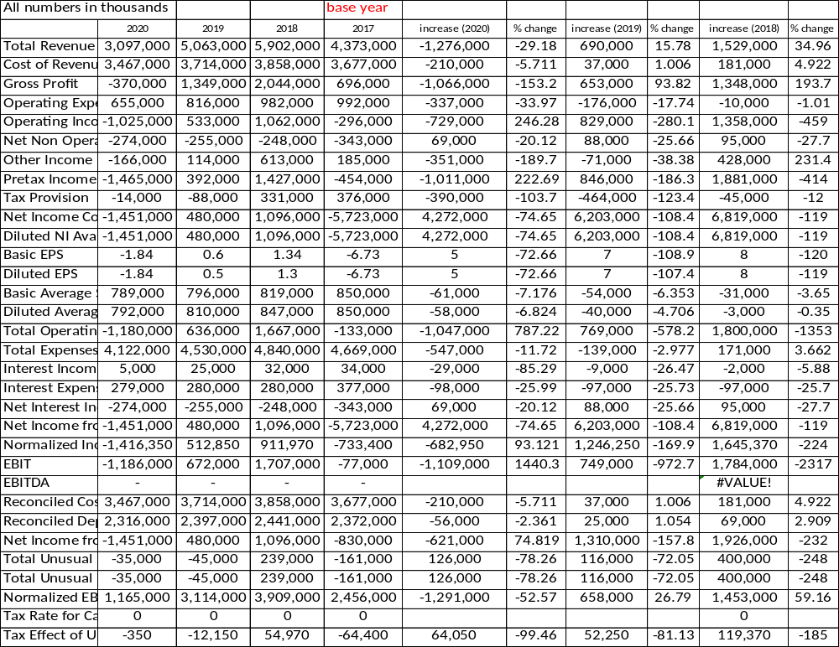
The horizontal analysis above measures the line of items on the financial statements with the base year (2017) for purposes of finding major divergent items or unexpected outcomes. The findings show that year 2020 performance had deteriorated significantly compared to the base year. Financial performances before financial year 2020 (pandemic year), shows a steady improvement in nearly all items on the financial statement.
Vertical analysis
Table 2: Marathon Oil Corporation Vertical analysis
All numbers in thousands | Estimated | 2020 | 2019 | 2018 | 2017
Total Revenue | 4,014,000 | 3,097,000 | 5,063,000 | 5,902,000 | 4,373,000
Cost of Revenue | 3,282,000 | 3,467,000 | 3,714,000 | 3,858,000 | 3,677,000
Proportional change (%) | 82 | 112 | 73 | 65 | 84
Gross Profit | 732,000 | -370,000 | 1,349,000 | 2,044,000 | 696,000
Proportional change (%) | 22 | -11 | 36 | 53 | 19
Operating Expense | 692,000 | 655,000 | 816,000 | 982,000 | 992,000
Proportional change (%) | 17 | 21 | 16 | 17 | 23
Operating Income | 40,000 | -1,025,000 | 533,000 | 1,062,000 | -296,000
Proportional change (%) | 1 | -33 | 11 | 18 | -7
Net Non Operating Interest Income Expense | -213,000 | -274,000 | -255,000 | -248,000 | -343,000
Proportional change (%) | -5 | -9 | -5 | -4 | -8
Other Income Expense | -345,000 | -166,000 | 114,000 | 613,000 | 185,000
Proportional change (%) | -9 | -5 | 2 | 10 | 4
Pretax Income | -518,000 | -1,465,000 | 392,000 | 1,427,000 | -454,000
Proportional change (%) | -13 | -47 | 8 | 24 | -10
Tax Provision | 24,000 | -14,000 | -88,000 | 331,000 | 376,000
Net Income Common Stockholders | -542,000 | -1,451,000 | 480,000 | 1,096,000 | -5,723,000
Proportional change (%) | -14 | -47 | 9 | 19 | -131
Diluted NI Available to Com Stockholders | -542,000 | -1,451,000 | 480,000 | 1,096,000 | -5,723,000
Basic EPS | - | -1.84 | 0.6 | 1.34 | -6.73
Diluted EPS | - | -1.84 | 0.5 | 1.3 | -6.73
Basic Average Shares | - | 789,000 | 796,000 | 819,000 | 850,000
Diluted Average Shares | - | 792,000 | 810,000 | 847,000 | 850,000
Total Operating Income as Reported | -270,000 | -1,180,000 | 636,000 | 1,667,000 | -133,000
Proportional change (%) | -7 | -38 | 13 | 28 | -3
Total Expenses | 3,974,000 | 4,122,000 | 4,530,000 | 4,840,000 | 4,669,000
Proportional change (%) | 99 | 133 | 89 | 82 | 107
Interest Income | - | 5,000 | 25,000 | 32,000 | 34,000
Proportional change (%) |  | 0 | 0 | 1 | 1
Interest Expense | - | 279,000 | 280,000 | 280,000 | 377,000
Proportional change (%) |  | 9 | 6 | 5 | 9
Net Interest Income | -213,000 | -274,000 | -255,000 | -248,000 | -343,000
Net Income from Continuing & Discontinued Operation | -542,000 | -1,451,000 | 480,000 | 1,096,000 | -5,723,000
Normalized Income | -265,400 | -1,416,350 | 512,850 | 911,970 | -733,400
EBIT | -121,000 | -1,186,000 | 672,000 | 1,707,000 | -77,000
Proportional change (%) | -3 | -38 | 13 | 29 | -2

Cost of Revenue increased in FY due to challenges of supply chain caused by the pandemic and generally, the performance was same for most other items in the financial statement. Cost of Revenue has been increasing for FYs 2018, 2019, and 2020 due to challenges of the oil industry where there was low demand and the industry could not scale down fixed costs in the production process. This is also reflected in the decline in gross profits. The operating expenses remained steady at about 20% over 2018-2020 which shows inability of the company to reduce operating expenses even as the revenues and gross profits was on the decline. There was a significant deterioration of performance in FY 2019 (gross profits, operating income) because of the low prices in the global market @ $56.99 per barrel compared to $65.23 in 2018. Basically, the fluctuations in financial performance echo the prices of oil in the market.
Trend Analysis
This trend analysis shows revenues and net income for Marathon Oil Corporation over selected period. The graph below shows a steady rise in revenue, gross profits, and net income up to 2018 and then took a steep downward move to 2020. This can be attributed to the downward prices in the world market due to reduced demand. This coincides with the US-China trade tensions which caused instability and slowdown in the global economy.
Graph 1: Marathon Oil Corporation assorted performance

Financial ratios
The financial ratios helps to determine whether an organization is adequately solvent, liquid, stable, or profitable (Zeller et al, 2019). Table 2 below captures assorted ratios for Marathon Oil Corporation.
Table 3: Assorted financial ratios
In million apart from ratios
Year | 2020 | 2019 | 2018 | 2017 | 2016 | 2015
Market Capitalization | 5,265 | 10,863 | 11,920 | 14,385 | 14,665 | 8,527
Market Cap Growth | -51.53% | -8.87% | -17.13% | -1.91% | 71.99% | -55.34%
Enterprise Value | 9,927 | 15,506 | 15,957 | 18,568 | 19,444 | 14,583
PE Ratio | -3.63 | 22.63 | 10.88 | -2.51 | -6.85 | -3.87
PS Ratio | 1.71 | 2.09 | 1.81 | 3.02 | 3.87 | 1.72
PB Ratio | 0.5 | 0.89 | 0.98 | 1.23 | 0.84 | 0.46
P/FCF Ratio | 40.5 | 54.59 | 24.78 | 1027.49 | -48.4 | -4.47
P/OCF Ratio | 3.57 | 3.95 | 3.69 | 7.24 | 16.28 | 5.41
EV/Sales Ratio | 3.26 | 2.93 | 2.41 | 4 | 5.28 | 3.07
EV/EBITDA Ratio | 9.08 | 5.01 | 3.87 | -7.05 | 15.73 | 233.92
EV/EBIT Ratio | -8.31 | 23.9 | 9.59 | -3.76 | -22.59 | -5.72
EV/FCF Ratio | 77.32 | 76.39 | 32.96 | 1362.7 | -65.97 | -7.96
Debt / Equity Ratio | 0.51 | 0.45 | 0.45 | 0.47 | 0.41 | 0.39
Debt / EBITDA Ratio | 4.88 | 1.81 | 1.34 | -2.03 | 5.72 | 111.95
Debt / FCF Ratio | 41.57 | 27.64 | 11.43 | 392.43 | -23.98 | -3.81
Current Ratio | 1.33 | 1.22 | 1.59 | 1.3 | 1.64 | 1.5
Quick acid | 1.23 | 1.13 | 1.39 | 1.22 | 1.44 | 1.23
Asset Turnover | 0.17 | 0.25 | 0.3 | 0.2 | 0.12 | 0.14
Return on Equity (ROE) | -13.00% | 3.90% | 9.10% | -47.20% | -11.40% | -11.20%
Return on Assets (ROA) | -7.70% | 2.30% | 5.10% | -24.40% | -6.60% | -6.40%
Profit Margin | -47.02% | 9.25% | 16.65% | -120.10% | -56.51% | -44.50%
Gross Margin | 62.70% | 74.62% | 78.47% | 72.40% | 61.74% | 61.86%
Return on Capital (ROIC) | -5.50% | 2.80% | 7.00% | -19.60% | -2.50% | -7.10%
Earnings Yield | -27.56% | 4.42% | 9.19% | -39.79% | -14.59% | -25.85%
FCF Yield | 2.47% | 1.83% | 4.04% | 0.10% | -2.07% | -22.39%
Dividend Yield | 1.20% | 1.49% | 1.42% | 1.18% | 1.12% | 5.40%
Payout Ratio | -4.40% | 33.90% | 15.40% | -3.00% | -7.70% | -20.90%
Buyback Yield / Dilution | 2.22% | 4.37% | 0.35% | -3.79% | -20.97% | 0.88%
Total Shareholder Return | 3.43% | 5.86% | 1.77% | -2.60% | -19.86% | 6.28%

Liquidity Ratios
Table 4: Current Ratio and Quick ratio
 | 2020 | 2019 | 2018 | 2017 | 2016 | 2015
Current Ratio | 1.33 | 1.22 | 1.59 | 1.3 | 1.64 | 1.5
Quick acid | 1.23 | 1.13 | 1.39 | 1.22 | 1.44 | 1.23
Working Capital | 399 | 390 | 1,089 | 598 | 1,425 | 861

The ratios are above 1 which indicates that the company’s current assets are able to pay for liabilities.
Table 5: Profitability Ratios
 | 2020 | 2019 | 2018 | 2017 | 2016 | 2015
Return on Equity (ROE) | -13.00% | 3.90% | 9.10% | -47.20% | -11.40% | -11.20%
Return on Assets (ROA) | -7.70% | 2.30% | 5.10% | -24.40% | -6.60% | -6.40%
Profit Margin | -47.02% | 9.25% | 16.65% | -120.10% | -56.51% | -44.50%
Gross Margin | 62.70% | 74.62% | 78.47% | 72.40% | 61.74% | 61.86%
Return on Capital (ROIC) | -5.50% | 2.80% | 7.00% | -19.60% | -2.50% | -7.10%
Operating Margin | -38.24% | 12.25% | 25.33% | -2.39% | -19.28% | -43.47%

The table above shows significant deterioration of profitability in most of the ratios between period 2015 and 2017 and between 2018 and 2020. As indicated earlier, the recent downward performance from 2018 coincides with a deterioration of demand and prices for oil in the market following trade tension and wars between the US and China. The period before 2018 coincides with slow in economic growth and the peak of Fracking technology which caused the US to increase its oil production hence suppressing prices. The trend had reversed in 2018 with better management of oil production but the US and China trade tensions reversed the trend and the lowest performance was in 2020.
Turnover Ratios
Table 6 below shows
Table 6: Turnover Ratios
 | 2020 | 2019 | 2018 | 2017 | 2016 | 2015
Inventory turnover | 15.55 | 15.68 | 12.77 | 10.04 | 6.45 | 12.07
Accounts Payable | 0.29 | 0.27 | 0.22 | 0.32 | 0.29 | 0.29
Account Receivables | 0.24 | 0.22 | 0.16 | 0.23 | 0.20 | 0.18

Higher levels are better because it shows how often the company sales inventory, pay suppliers/creditors or turn receivables into cash. The Inventory turnover trend shows improvement over the years. Accounts Payable and Account Receivables shows a steady level. However, appendix 1 shows comparison of Marathon Oil Corporation trailing 12 months (TTM) and the industry average. Largely, the MRO Receivables’ ratio of 0.24 is poor than the industry averages of 10.2 while the MRO Inventory turnover of 15.55 is better than the industry ratio of 12.79.
Solvency Ratios
Debt Equity Ratio

 | 2020 | 2019 | 2018 | 2017 | 2016 | 2015
Debt / Equity Ratio | 0.51 | 0.45 | 0.45 | 0.47 | 0.41 | 0.39
Debt / FCF Ratio | 41.57 | 27.64 | 11.43 | 392.43 | -23.98 | -3.81
The trend shows Debt / Equity Ratio increase in 2020 after a steady level from 2016 to 2019. This can be attributed to the hard financial times in the year 2020 which caused the company to borrow more.
Financial Leverage
 | 2020 | 2019 | 2018 | 2017 | 2016 | 2015
Total Assets | 17,956 | 20,245 | 21,321 | 22,012 | 31,094 | 32,311
Shareholders' Equity | 10,561 | 12,153 | 12,128 | 11,708 | 17,541 | 18,553
Total Assets/Equity | 1.70 | 1.67 | 1.76 | 1.88 | 1.77 | 1.74

The Financial Leverage refers to the debt a firm uses to finance its assets. The Financial Leverage for MRO remains steady near 1.7. This average ratio is relatively high and can be considered a risky level by potential investors and lenders.
Valuation for Marathon Oil Corporation
Discounted Cash Flow Model Calculation
The DCF Value is calculated by forecasting or estimating future free cash flow and discounting the same at selected Discount Rate as in the table below. The calculation uses a Discount Rate of 7.80% and 10% to show present values and the rate can be adjusted to show sensitivity
 | 12/31/2021 | 12/31/2022 | 12/31/2023 | 12/31/2024 | 12/31/2025 | Terminal
 | forecasted | forecasted | forecasted | forecasted | forecasted | forecasted
NET INCOME
Revenue | 4,893 | 5,030 | 4,662 | 4,811 | 4,940 | 5,045
Net Margin | 16.44% | 18.31% | 15.84% | 16.37% | 16.91% | 17.44%
Net Income | 804 | 921 | 738 | 788 | 835 | 880
FREE CASH FLOW TO EQUITY
Net CapEx | 917 | 851 | 703 | 638 | 565 | 485
Debt Ratio | 50.66% | 50.66% | 50.66% | 50.66% | 50.66% | 50.66%
Net CapEx Financed by Equity | 452 | 420 | 347 | 315 | 279 | 239
FCFE | 1,257 | 1,341 | 1,085 | 1,102 | 1,114 | 1,119
PRESENT VALUE
Discount Rate | 7.80% | 7.80% | 7.80% | 7.80% | 7.80% | 7.80%
Present Value (7.8%) | 1,166 | 1,154 | 866 | 816 | 765 | 9,855
Discount Rate | 10.00% | 10.00% | 10.00% | 10.00% | 10.00% | 10.00%
Discount factor | 0.91 | 0.83 | 0.75 | 0.68 | 0.62
Present Value (10%) | 1,142.73 | 1,108.26 | 815.18 | 752.68 | 691.71 | 4,510.56

Marathon Valuation Trend
Investors need to know Marathon Oil's actual value for then to make sound investment decisions. The real value provides a more accurate general view of the company's financial worth over a specified period of time because such information allows analysts and investors to forecast earnings more effectively and efficiently. The use of market capitalization and enterprise value provide a good way to gauge the company’s value and for investors to use it to make decisions. Graph 2 below shows Marathon Oil's actual value over a period from 2012 to 2021. The valuation has been on a down trend but with some improvements in 2020.

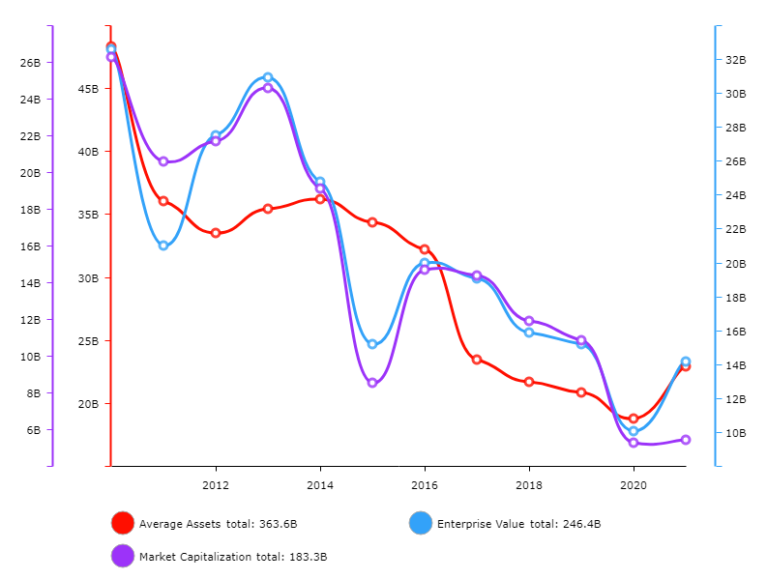
Recommending the corporation finance
The above analysis has considered many aspects of historical performance and also forecast of valuation into the future. a comparison of the financial ratio with the industry averages (industry averages in appendix 1) shows mixed performance but slightly skewed towards below industry performance. for example, profitability ratios for the company on Return on Equity 5YA @ 4.18, Return on Assets 5YA @ -11.7, Pretax margin 5YA @-26.85, Operating margin 5YA@-26.44, and Gross Margin 5YA @ 46.77 are relatively better than the industry averages. Liquidity Ratios are also healthy despite being slightly below industry averages. The debt to equity for the company, about half of the company finances are through debt which is healthy. In terms of asset leverage, the ratio of 1.7 shows that more assets are financed using debt or loan and that the equity holders have less claim on such assets. A ratio of 1.7 is still not considered risky and therefore it is healthy in terms of financing more assets by a balanced issuance of debt and equity.
Based on the above, Marathon Oil Corporation is can manage to use more debt funds to finance its capital expenditure which is pegged at $ $1,795,600. The analysis above (valuation, financial ratios, and financial performance trends) shows that Marathon Oil Corporation is a relatively stable, liquid, solvent, and profitable company. The oil industry is peaking as the global economy rebound from a poor global economic performance due to the pandemic. Basically, the global economy and environment is looking upwards and this is a favorable environment for the company. Based on these factors, Marathon Oil Corporation can be able to achieve a performance that will enable payment of interests and because the assets are not highly committed into past loans, fresh loan for the capital expenditure would be appropriate. Other advantages of the debt financing method include: the owners retain business ownership, it allows tax deductions, debt can fuel growth, use of long-term debt can eradicate the company’s reliance on expensive debt, it is easier to plan payment, loans come in different forms and offer flexibility (many options), provide opportunity for access to customized terms to suit specific needs and situations (Ling, 2020). The disadvantages of the debt financing method include the amount must be repaid to the lender even when the business is performing poorly, High rates of interests, and it can impacts company’s credit rating.
Overall, Marathon Oil Corporation capital expenditure will be $1,795,600 or (10%* 17,956, 000) and since the income return from the new asset will not exceed cost of borrowing, then the considerations is on valuation, financial health of the company, and the business conditions. Based on these factors, debt financing will be appropriate for Marathon Oil Corporation.

References
Annualreports.com (2021). Marathon oil Corporation Retrieved from: https://www.annualreports.com/Company/marathon-oil-corporation
Investing.com (2021). Marathon Oil Corporation (MRO). Retrieved from: https://www.investing.com/equities/marathon-oil-ratios
Ling, Z. (2020). A research on the effect of equity and debt financing on technological innovation performance. Science Research Management, 41(8), 95.
Marketwatch.com (2021). Financials balance-sheet. Retrieved from: https://www.marketwatch.com/investing/stock/mro/financials/balance-sheet
Zeller, T., Kostolansky, J., & Bozoudis, M. (2019). An IFRS-based taxonomy of financial ratios. Accounting Research Journal.

‘

Appendix 1: Company and Industry ratio
Name | Company | Industry
P/E Ratio TTM | - | 44.72
Price to Sales TTM | 3.52 | 12.48
Price to Cash Flow MRQ | 202.12 | 715.66
Price to Free Cash Flow TTM | 12.34 | 98.7
Price to Book MRQ | 1.26 | 2.58
Price to Tangible Book MRQ | 1.25 | 3.05
Gross margin TTM | 0.8648 | 46.68
Gross Margin 5YA | 0.8251 | 46.77
Operating margin TTM | -0.0835 | -10.85
Operating margin 5YA | 0.0029 | -26.44
Pretax margin TTM | -0.1365 | -14.13
Pretax margin 5YA | -0.056 | -26.85
Net Profit margin TTM | -0.1428 | -16.87
Net Profit margin 5YA | -0.1252 | -29.3
Revenue/Share TTM | 4.8 | 68.01
Basic EPS ANN | -1.83 | -6.29
Diluted EPS ANN | -1.83 | -6.3
Book Value/Share MRQ | 13.48 | 54.24
Tangible Book Value/Share MRQ | 13.48 | 51.69
Cash/Share MRQ | 1.23 | 9.22
Cash Flow/Share TTM | 1.98 | 9.72
Return on Equity TTM | -0.0497 | 1.71
Return on Equity 5YA | -0.0415 | 4.18
Return on Assets TTM | -0.0298 | 2.52
Return on Assets 5YA | -0.0236 | -11.7
Return on Investment TTM | -0.0321 | 3.63
Return on Investment 5YA | -0.0256 | 3.48
EPS(MRQ) vs Qtr. 1 Yr. Ago MRQ | 1.0214 | 690.58
EPS(TTM) vs TTM 1 Yr. Ago TTM | 0.1717 | 715.07
5 Year EPS Growth 5YA | - | -17.19
Sales (MRQ) vs Qtr. 1 Yr. Ago MRQ | 3.1679 | 117.64
Sales (TTM) vs TTM 1 Yr. Ago TTM | -0.0604 | 6.96
5 Year Sales Growth 5YA | -0.0863 | 0.98
5 Year Capital Spending Growth 5YA | -0.1736 | -6.63
Quick Ratio MRQ | 1.27 | 1.4
Current Ratio MRQ | 1.32 | 1.64
LT Debt to Equity MRQ | 0.4584 | 69.65
Total Debt to Equity MRQ | 0.4615 | 74.03
Efficiency
Asset Turnover TTM | 0.21 | 0.51
Inventory Turnover TTM | 6.62 | 12.79
Revenue/Employee TTM | 2.27M | 2.31M
Net Income/Employee TTM | -324.16K | 61.78K
Receivable Turnover TTM | 4.66 | 10.2
Dividend Yield ANN | 0.0142 | 3.19
Dividend Yield 5 Year Avg. 5YA | 0.0132 | 3.91
Dividend Growth Rate ANN | -0.1807 | 14.28
Payout Ratio TTM | - | 105.89

https://www.investing.com/equities/marathon-oil-ratios

